**DAILY ONLINE ACTIVITIES SUMMARY**

|  |  |  |  |  |  |  |  |
| --- | --- | --- | --- | --- | --- | --- | --- |
| **Date:** | **17 June 2020** | | | | **Name:** | **KHATHEEJA SAFREENA.** | |
| **Sem & Sec** | **4th sem, 2nd year** | | | | **USN:** | **4AL18CS037.** | |
| **Online Test Summary** | | | | | | | |
| **Subject** | | **----------------** | | | | | |
| **Max. Marks** | | **---** | | **Score** | | **-------** | |
| **Certification Course Summary** | | | | | | | |
| **Course** | **INTRODUCTION TO INFORMATION SECURITY.** | | | | | | |
| **Certificate Provider** | | | **GreatLearning** | **Duration** | | | **6 hours** |
| **Coding Challenges** | | | | | | | |
| **Problem Statement: 1.Write a C Program to Count numbers that don’t contain 3** | | | | | | | |
| **Status: Executed** | | | | | | | |
| **Uploaded the report in Github** | | | | **Yes** | | | |
| **If yes Repository name** | | | | [http://shafreenasharief / lockdown-coding](http://shafreenasharief / lockdown-coding" \o "http://shafreenasharief / lockdown-coding)  [http://shafreenasharief / locked-down--certification-course](http://shafreenasharief / locked-down--certification-course" \o "http://shafreenasharief / locked-down--certification-course)  [http://shafreenasharief / Daily\_Report](http://shafreenasharief / Daily_Report" \o "http://shafreenasharief / Daily_Report) | | | |
| **Uploaded the report in slack** | | | | **Yes** | | | |

Certification Course Details: (Attach the snapshot and briefly write the report for the same)

Coding Challenges Details: (Attach the snapshot and briefly write the report for the same)

**CERTIFICATION COURSE SUMMARY:**

Today I started new course **INTRODUCTION TO INFORMATION SECURITY** through **GREAT LEARNING** the course is secluded for 6hrs. After the completion of course, certificate will be provided. I completed all the module .I attempted quiz ,which gave me a clear veiw about the topics that were thought and discussed.It consists of 7 modules which also include assessments.

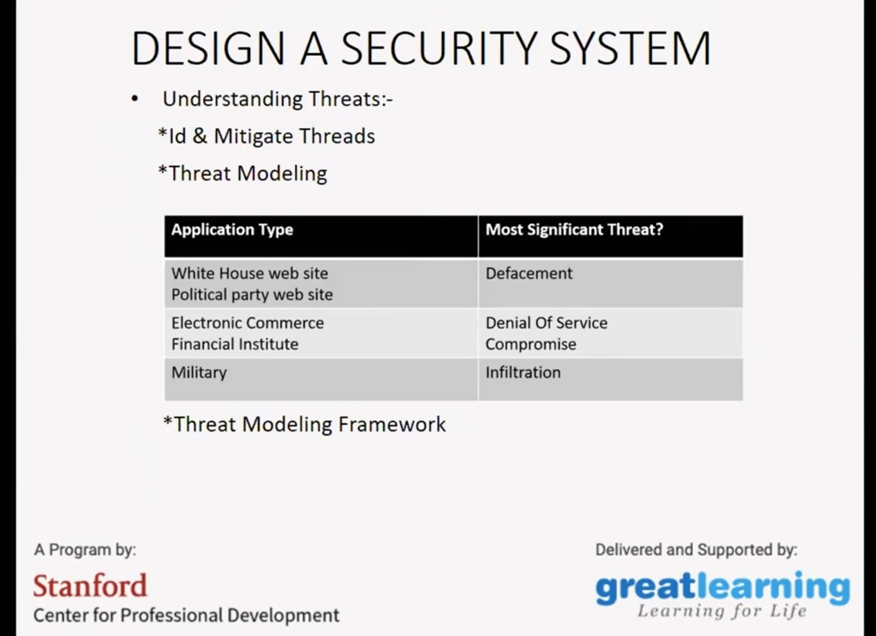

**CODING CHALLENGES**

Today I solved coding challenge,

**Write a C Program to Count numbers that don’t contain 3**

Given a number n, write a function that returns count of numbers from 1 to n that don’t contain digit 3 in their decimal representation.  
**Examples:**  
**Input:** n = 10  
**Output:** 9  
Here input is 10 means the numbers within 10 are 1,2,3,4,5,6,7,8,9,10 in this series 3 occurs only 1 time so answer is 9

**More examples**  
Input: n = 45  
Output: 31  
// Numbers 3, 13, 23, 30, 31, 32, 33, 34,  
// 35, 36, 37, 38, 39, 43 contain digit 3.

Input: n = 578  
Output: 385

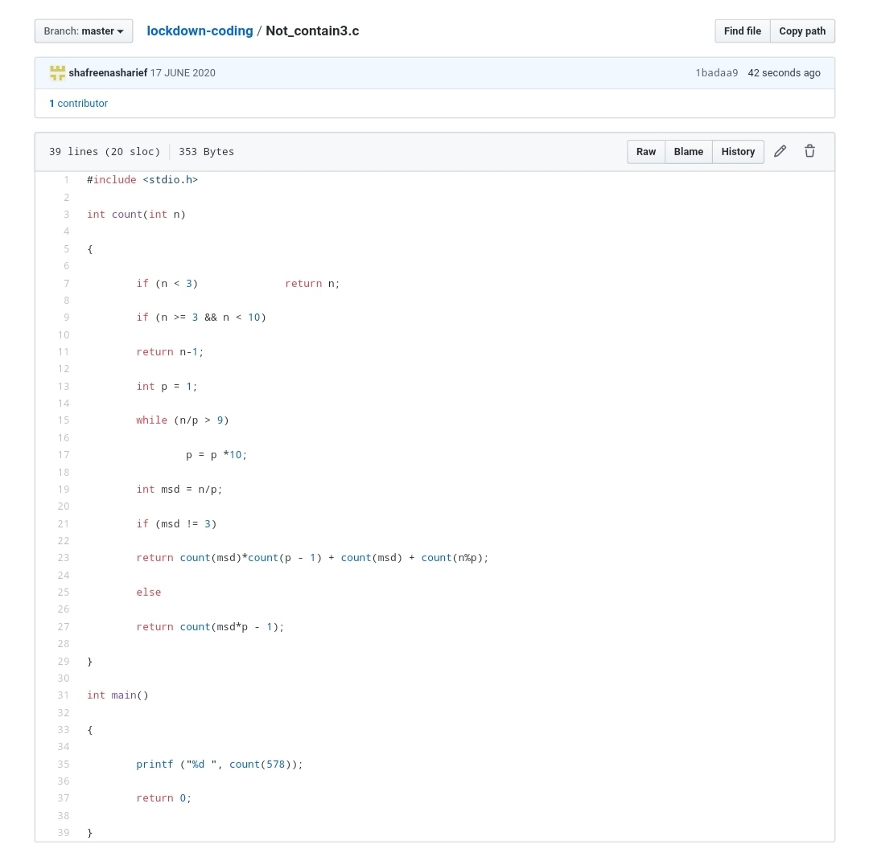

**SOLUTION** : I have uploaded the solution of the above 3 coding problems in my GitHub repository.

[http://shafreenasharief / lockdown-coding](http://shafreenasharief / lockdown-coding" \o "http://shafreenasharief / lockdown-coding)

[http://shafreenasharief / locked-down--certification-course](http://shafreenasharief / locked-down--certification-course" \o "http://shafreenasharief / locked-down--certification-course)

[http://shafreenasharief / Daily\_Report](http://shafreenasharief / Daily_Report" \o "http://shafreenasharief / Daily_Report)